**Source Code Management and Version Control Using Git and GitHub**

In Normal way a project which was dealied by three persons

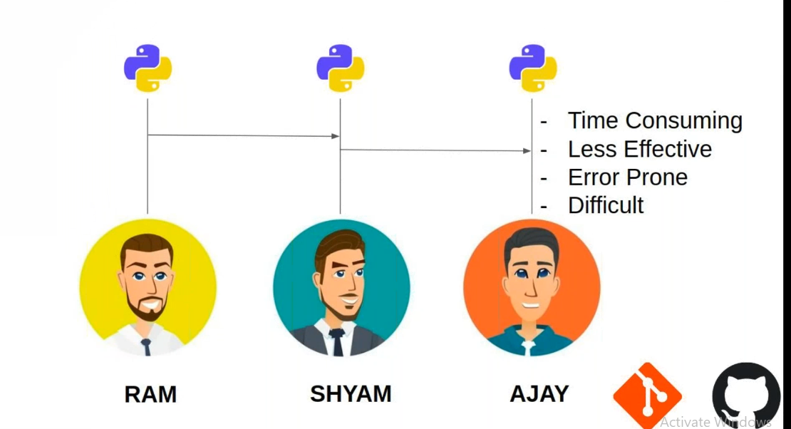

Using git

Git is a distributed Version Control System

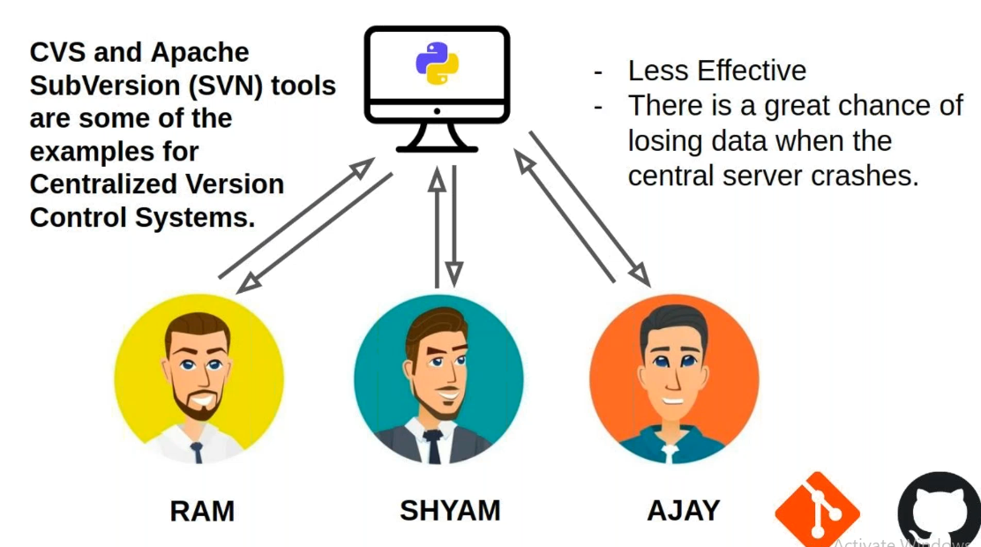

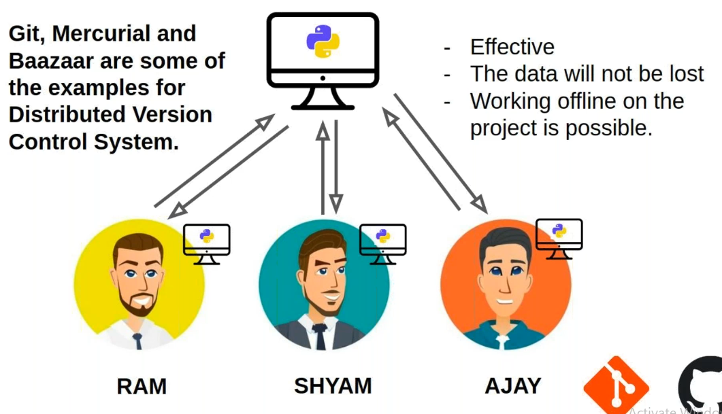

**Offical link :-** <https://git-scm.com/> SCM (software code management)

$ git --version 🡪 this command is used to check the version of git installed on your computer.

$ git config --global user.name “username” 🡪Will set your name on git

$ git config –global user.email “useremail.com” 🡪 Will set your email on git

$ git config user.name 🡪return the name set to git

$ git config user.email 🡪 return the email set to git

Let’s start new project

Working directory=Project Folder

Repository 🡪 is the place where you will save the project versions.

$ git init 🡪it will initialize a new repository.it will also create a folder called .git(is invisiable by default).All the work (versions) which ever you want to save will be saved inside this folder. Caution: don’t access this floder with out a valid and important need.

$ touch filename.txt 🡪 will create a file

$ cat filename.txt 🡪will display the contents of the file.

This the process of project stores in repository.We can not add the file as snapshot directly to the repostory

Ry to 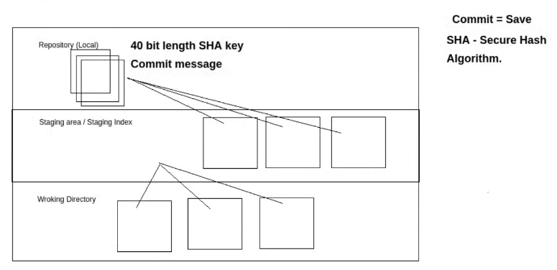

$ git add <filename1><filename2> 🡪will add the given files into staging area

$ git add . 🡪will add all the files in the working directory to the staging area

$ git rm --cached <filename1><filename2> 🡪will remove the given files from the staging area

$ git status 🡪will give the status of all the files in the working directory

$ git commit 🡪command will commit(save) all the files that are present in the staging area in to repository as a snapshot(will have 40 char length auto generated SHA key and a commit message)

vim editor if you want to come out after giving the commit message

Ubuntu 🡪 Ctrl + o

🡪enter

🡪Ctrl + x

Windows 🡪 esc

🡪:wq(save and exit the vim editor)

$ git commit –m “Initial Commit” 🡪 command will commit(save) all the files that are present in the staging area in to repository as a snapshot(will have 40 char length auto generated SHA key and a commit message)

$ git log 🡪 will give the commit log in reverse chronological order

$git log --reverse 🡪will give the commit log in chronological oreder

$ git log --oneline 🡪will make the commit log shorter by only displaying the first 7 characters of commit SHA key the commit message.

$ git checkout <7/40 char SHA KEY> 🡪 will take your project how it was during the commit.

$ git checkout master 🡪will get you to the normal state of the project